Belimo Energy Valve™
- Measures Energy The integrated BTU meter provides accurate coil performance. The data is used to verify system performance during commissioning and act as a baseline standard for system performance over time. This feature contributes to LEED points.
- Controls Power The built-in Power Control logic provides a linear heat transfer regardless of system temperature variations offering precise energy control. This mode improves comfort and allows for load shedding.
- Manages Delta T The Belimo Delta T Manager™ algorithm monitors the coil performance and optimizes the available energy of the coil by maintaining the Delta T. This solves low delta T syndrome.

Applications
The Energy Valve is a two-way pressure independent valve that optimizes, documents and proves water coil performance. Using the Electronic Pressure Independent Valve (ePIV) platform, the Energy Valve measures the coil energy using an embedded electromagnetic or ultrasonic flow sensor, water supply, and return temperature sensors. The Energy Valve is ideal for water-side control of heating and cooling systems for AHUs and any water coil (equal percentage: heating/cooling application).

Non-Spring
Return

Valve Sizes: ½” - 6”
ANSI 125 or ANSI 250 2½” - 6”
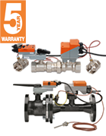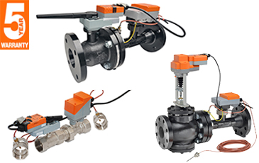

Electronic
Fail-Safe

Valve Sizes: ½” - 6”
ANSI 125 or ANSI 250 2½” - 6”

